Memorandum of Understanding

for joint actions by the

Maritime Education and Training Network

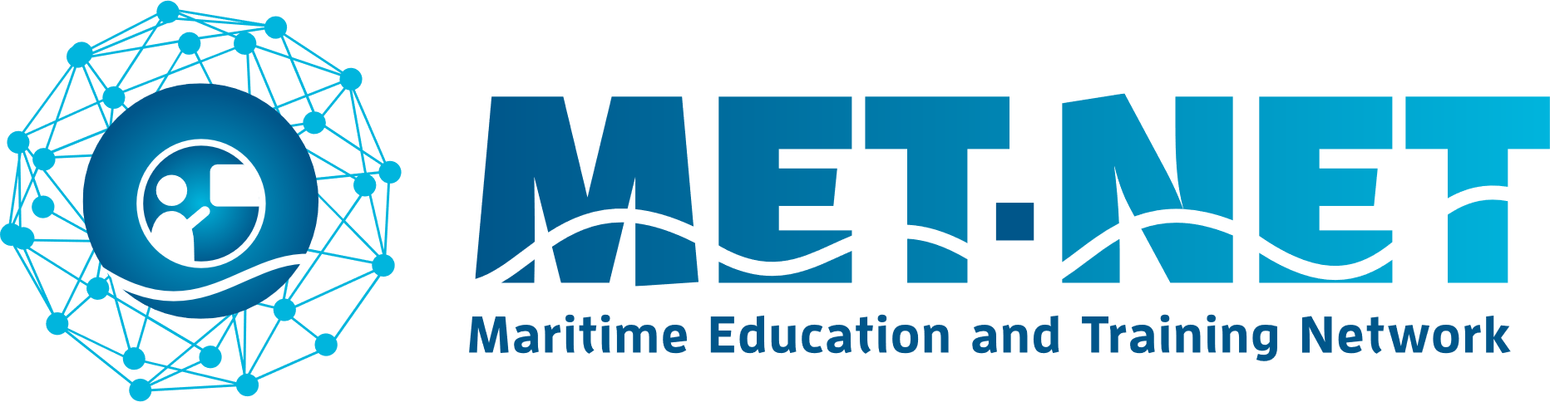

Logo Institute

Name institute:

Name representative and function:

Signature representative:

Date and Place:

**Chapter 1: Background**

We recognize the fact that we all are governed by similar rules and regulations in maritime transport. Despite the fact that we are aware of the different backgrounds in various educational systems in Europe, it is our aim to come to a structured cooperation. Our common goal is to provide current and future maritime professionals with the best possible education. This asks for collaboration regarding amongst others the development of curricula, the exchange of teachers and students and a common representation in important European forums. By participating in METNET, education providers can benefit from increased visibility, access to valuable resources, and networking opportunities that strengthen existing connections between our institutions. In doing so, we can ensure the high quality of trained maritime personnel, through intensifying the already existing informal connections between our educational institutes. Thus, making optimal use of all available synergies.

**Chapter 2: Purpose**

MET-NET initially will be open to all public maritime education providers in- and outside SkillSea, and to the current private maritime education providers in SkillSea. MET-NET will provide a platform for the exchange of information, knowledge and expertise and enables its members to communicate and share their views on specific educational issues. MET-NET partners also can develop proposals for relevant European grant programmes such as Erasmus+ and others.

MET-NET will also be a partner for the communication with stakeholders in maritime transport, such as European research institutes, social partners and other policy makers.

**Chapter 3: Structure of MET-NET**

The current founding partners of MET-NET will become the first steering committee of MET-NET after the signing of this MoU. The steering committee will prepare:

* the formalisation of MET-NET,
* the first meeting of all institutions that have signed this MoU,
* the election of the first chairman, vice-chairman and secretary of MET-NET,
* promote MET-NET as communication platform to the stakeholders and
* initiate initiatives for the exchange of knowledge, students and teachers.

Ultimately, after one year the positions of the steering committee will be reconsidered in a general meeting of MET-NET.

**Chapter 4: Signature and effective date**

The parties confirm the intention to participate in, or to promote their institute’s participation in, the Maritime Education and Training Network (MET-NET) by signing this Memorandum of Understanding.

Signature is given by the authorized representative.

A first version of the work plan will be attached to the MoU on becoming effective.